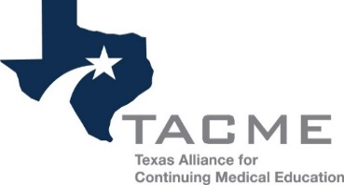

2018 Texas CME Conference
Abstract Proposal

Abstract Guidelines and Submission:
Complete the proposal and email to casey.harrison@texmed.org by December 1, 2017. The 2018 Texas CME Conference Planning Committee will review abstracts. Content submitted will remain confidential. Applicants will be notified as to whether their abstract has been accepted. If accepted, applicants and all co-presenters must register for the conference. Presenters receive a reduced conference registration fee.

Topic suggestions include accreditation, learning strategies, outcomes/assessment, performance/quality improvement, professional advancement, technology and best practices.
Contact Information
Name
Email
Phone
Presentation Information
Title
Objective(s)
Teaching method(s)  (Check all that apply) | Didactic lecture  Workshop  Panel discussion | Case Studies  Other:
Target Audience  (Check all that apply) | Beginner  Intermediate  Advanced
Presenter(s)
Position(s)/Title(s)
Organization(s)

